Lab Cloudfront

Create a Static website in s3 bucket.

Upload folder from this location

<https://github.com/amitopenwriteup/static-website-example.git>

1. Click on cloudfront service and click on Create a CloudFront distribution

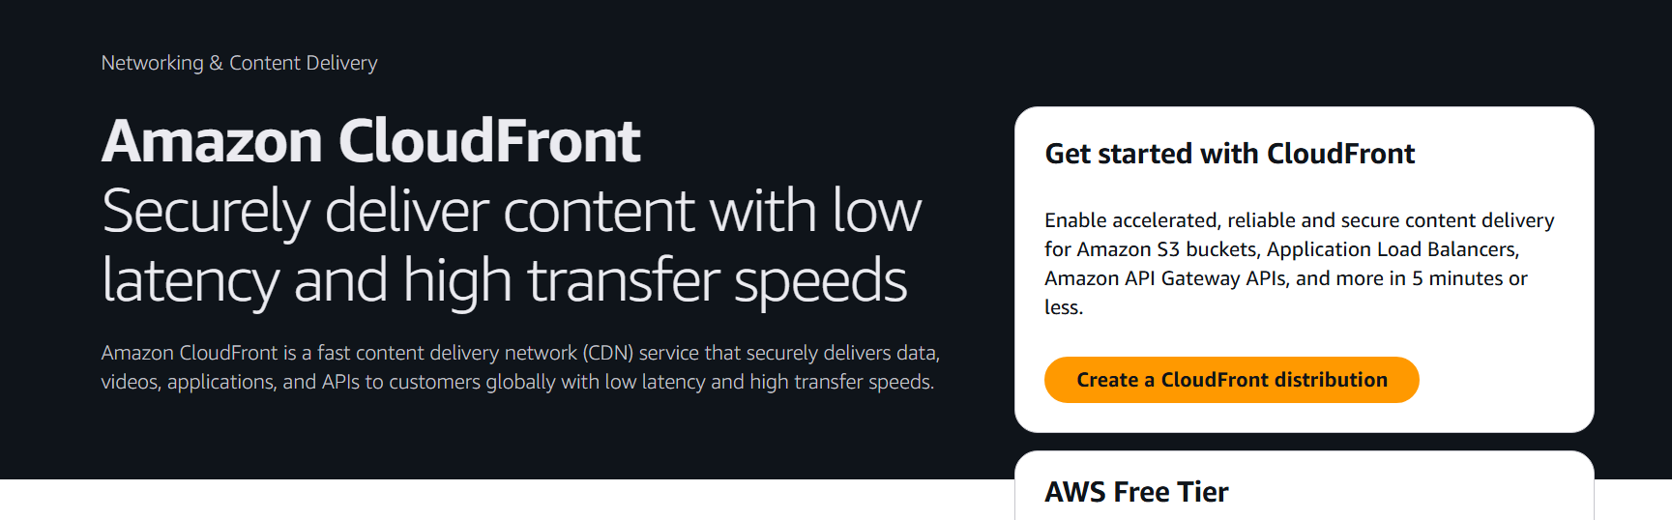

1. Provide the source info

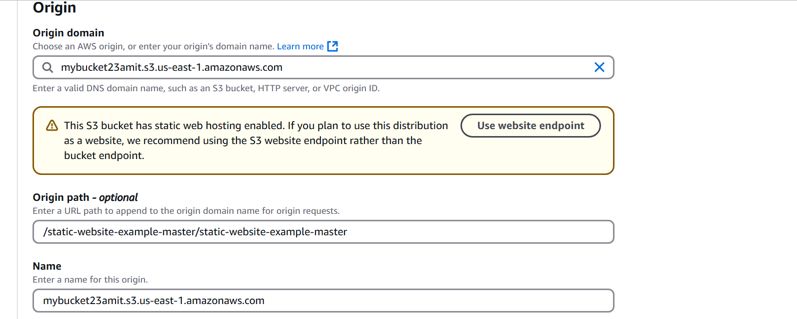

3)

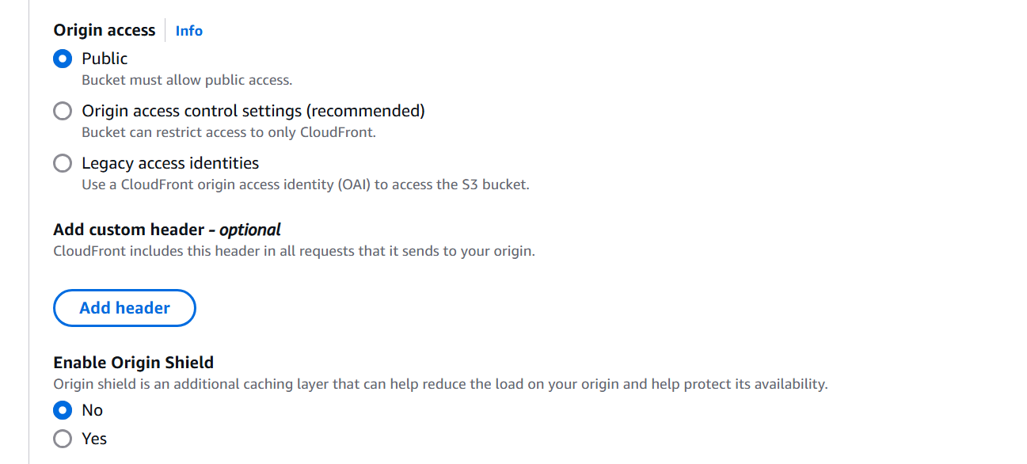

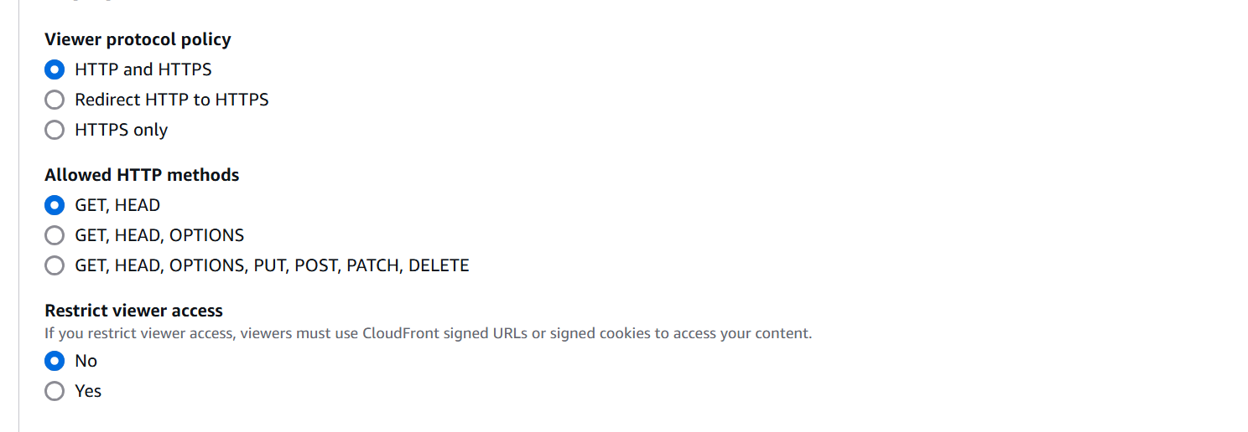

WAF disable

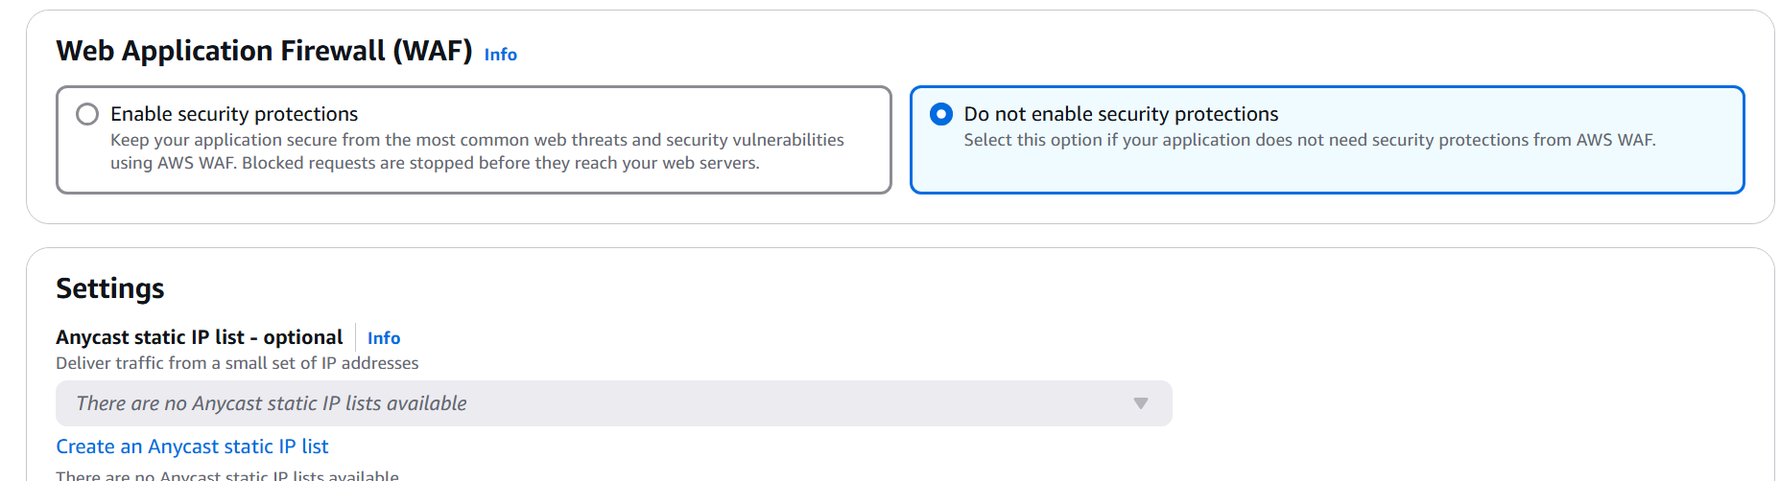

Click on Create distribution

